Cans For Cancer
“You Can Do It!”
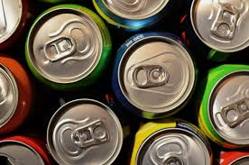
Cans For Cancer is a service that collects soda cans throughout the Abbeville, SC community to turn into the recycling center in exchange for revenue. All profit will be given to the local Relay for Life pageant for the following year. Cans For Cancer also accept donations as well!
Contact: Jessica Washington, (864)828-0821 Email: JWCansForCancer@gmail.com

